**Actual Fucking Instructions for Module 3**

Question 1: Using Fragments

1. Create a new project in Android Studio
   1. Choose **empty views activity**
   2. Name it **“Fragments”**
   3. Make sure the language is set to **Java**
   4. Select **API 25: Android 7.1.1 (Nougat)**
2. Open the activity_main.xml file and replace any code with this:

<?xml version="1.0" encoding="utf-8"?>  
<LinearLayout android:orientation="vertical"  
 xmlns:android="http://schemas.android.com/apk/res/android"  
 xmlns:tools="http://schemas.android.com/tools"  
 android:layout_width="match_parent"  
 android:layout_height="match_parent"  
 tools:context="com.example.fragments.MainActivity">  
  
 <fragment  
 android:name="com.example.fragments.Fragment1"  
 android:id="@+id/fragment1"  
 android:layout_weight="1"  
 android:layout_width="fill_parent"  
 android:layout_height="match_parent" />  
  
 <fragment  
 android:name="com.example.fragments.Fragment2"  
 android:id="@+id/fragment2"  
 android:layout_weight="1"  
 android:layout_width="fill_parent"  
 android:layout_height="match_parent" />  
  
</LinearLayout>

1. If all the text goes onto one line, use ctrl+a to select all the text and then use ctrl+alt+L to auto format the code.

// When you put in some of the code, there will be some errors, but when you add the other files, the errors will go away

1. Open the **res** folder and right-click on the **layout** folder. Hover over **new**, and go down to **fragments**, and create a new **fragment (blank)**. Name the file fragment1 and replace any code in the file with:

<?xml version="1.0" encoding="utf-8"?>  
 <LinearLayout  
 xmlns:android="http://schemas.android.com/apk/res/android"  
 android:orientation="vertical"  
 android:layout_width="fill_parent"  
 android:layout_height="fill_parent"  
 android:background="#00FF00">  
  
 <TextView  
 android:layout_width="fill_parent"  
 android:layout_height="wrap_content"  
 android:text="This is fragment #1"  
 android:textColor="#000000"  
 android:textSize="25sp"/>  
</LinearLayout>

1. Create another **fragment(blank)** file like you did for step 3, and name it fragment2 and replace any code in the file with

<?xml version="1.0" encoding="utf-8"?>  
 <LinearLayout  
 xmlns:android="http://schemas.android.com/apk/res/android"  
 android:orientation="vertical"  
 android:layout_width="fill_parent"  
 android:layout_height="fill_parent"  
 android:background="#FFFE00">  
  
 <TextView  
 android:layout_width="fill_parent"  
 android:layout_height="wrap_content"  
 android:text="This is fragment #2"  
 android:textColor="#000000"  
 android:textSize="25sp"/>  
</LinearLayout>

1. Right-click the **com.example.fragments** folder and hover over **new**. Select **Java Class** and name it Fragment1 and replace any code in the file with:

package com.example.fragments;  
import android.app.Fragment;  
import android.os.Bundle;  
import android.view.LayoutInflater;  
import android.view.View;  
import android.view.ViewGroup;  
public class Fragment1 extends Fragment {  
@Override  
 public View onCreateView(LayoutInflater inflater,  
 ViewGroup container, Bundle savedInstanceState) {  
 //---Inflate the layout for this fragment---  
 return inflater.inflate(R.layout.*fragment1*, container, false);  
 }  
}

1. Create another **Java Class** file like you did in step 5, and name it Fragment2 and replace any code in the file with:

package com.example.fragments;  
import android.app.Fragment;  
import android.os.Bundle;  
import android.view.LayoutInflater;  
import android.view.View;  
import android.view.ViewGroup;  
public class Fragment2 extends Fragment {  
 @Override  
 public View onCreateView(LayoutInflater inflater,  
 ViewGroup container, Bundle savedInstanceState) {  
 //---Inflate the layout for this fragment---  
 return inflater.inflate(R.layout.*fragment2*, container, false);  
 }  
}

1. Run the app and take a screenshot. It should look like this:

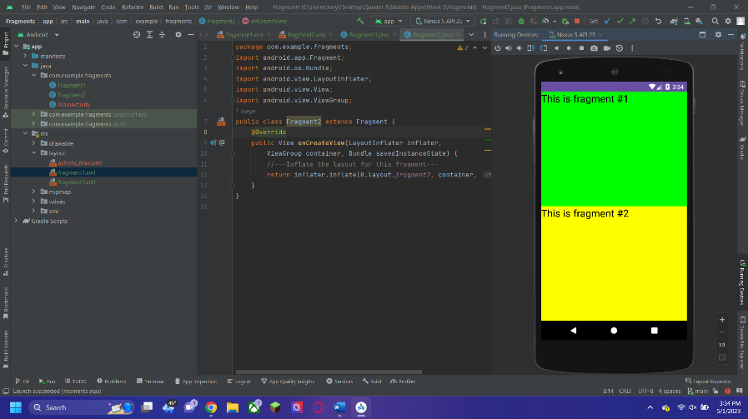

1. Now save and close the project.

Question 2: Adding Fragments During Runtime

// I assume we are supposed to do all these questions in separate projects so…

1. Copy and paste the project we just made and open the project in android studio.

// For my assignment I just named each project Fragment-Q1, Fragment-Q2, etc.

1. Open the **MainActivity.java** file and replace the code with this:

package com.example.fragments;  
import android.app.Activity;  
import android.app.FragmentManager;  
import android.app.FragmentTransaction;  
import android.os.Bundle;  
import android.util.DisplayMetrics;

public class MainActivity extends Activity {  
 */** Called when the activity is first created. */* @Override  
 public void onCreate(Bundle savedInstanceState) {  
 super.onCreate(savedInstanceState);  
 FragmentManager fragmentManager = getFragmentManager();  
 FragmentTransaction fragmentTransaction = fragmentManager.beginTransaction();  
 //---get the current display info---  
 DisplayMetrics display = this.getResources().getDisplayMetrics();  
 int width = display.widthPixels;  
 int height = display.heightPixels;  
 if (width> height){  
 //---landscape mode---  
 Fragment1 fragment1 = new Fragment1();  
 // android.R.id.content refers to the content  
 // view of the activity  
 fragmentTransaction.replace(android.R.id.*content*, fragment1);  
 }  
 else{  
 //---portrait mode---  
 Fragment2 fragment2 = new Fragment2();  
 fragmentTransaction.replace(android.R.id.*content*, fragment2);  
 }  
 fragmentTransaction.commit();  
 }  
}

1. Run the app and take another screenshot of the result. It should look like this:

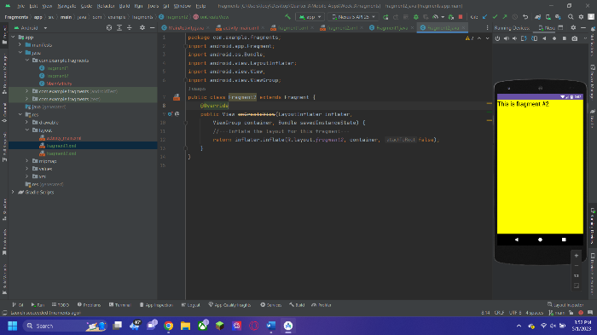

1. Above the device on the right, there is a button to rotate the phone to put it into landscape mode. It looks like this:

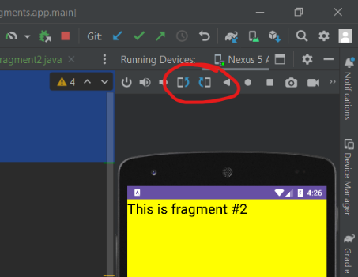

1. Take a new screenshot of the result. It should look like this:

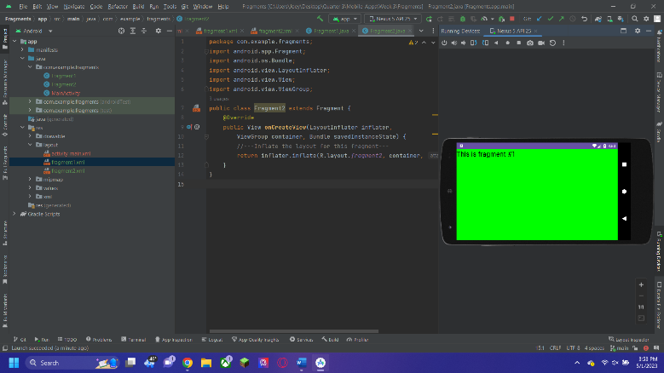

1. Now save and close the project.

Question 3: Understanding the Life Cycle of a Fragment

1. Copy and paste the 2nd project and open the new one.
2. Open Fragment1.java and replace the code with this:

package com.example.fragments;  
import android.app.Activity;  
import android.app.Fragment;  
import android.os.Bundle;  
import android.util.Log;  
import android.view.LayoutInflater;  
import android.view.View;  
import android.view.ViewGroup;  
public class Fragment1 extends Fragment {  
 @Override  
 public View onCreateView(LayoutInflater inflater, ViewGroup container, Bundle savedInstanceState) {  
 Log.*d*("Fragment 1", "onCreateView");  
 //---Inflate the layout for this fragment---  
 return inflater.inflate(R.layout.*fragment1*, container, false);  
 }  
 @Override  
 public void onAttach(Activity activity) {  
 super.onAttach(activity);  
 Log.*d*("Fragment 1", "onAttach");  
 }  
 @Override  
 public void onCreate(Bundle savedInstanceState) {  
 super.onCreate(savedInstanceState);  
 Log.*d*("Fragment 1", "onCreate");  
 }  
 @Override  
 public void onActivityCreated(Bundle savedInstanceState) {  
 super.onActivityCreated(savedInstanceState);  
 Log.*d*("Fragment 1", "onActivityCreated");  
 }  
 @Override  
 public void onStart() {  
 super.onStart();  
 Log.*d*("Fragment 1", "onStart");  
 }  
 @Override  
 public void onResume() {  
 super.onResume();  
 Log.*d*("Fragment 1", "onResume");  
 }  
 @Override  
 public void onPause() {  
 super.onPause();  
 Log.*d*("Fragment 1", "onPause");  
 }  
 @Override  
 public void onStop() {  
 super.onStop();  
 Log.*d*("Fragment 1", "onStop");  
 }  
 @Override  
 public void onDestroyView() {  
 super.onDestroyView();  
 Log.*d*("Fragment 1", "onDestroyView");  
 }  
 @Override  
 public void onDestroy() {  
 super.onDestroy();  
 Log.*d*("Fragment 1", "onDestroy");  
 }  
 @Override  
 public void onDetach() {  
 super.onDetach();  
 Log.*d*("Fragment 1", "onDetach");  
 }  
}

1. Run the code and rotate the phone again to make it into landscape mode. At the bottom-left of the window, there is a tab called **logcat**. It should look like this:

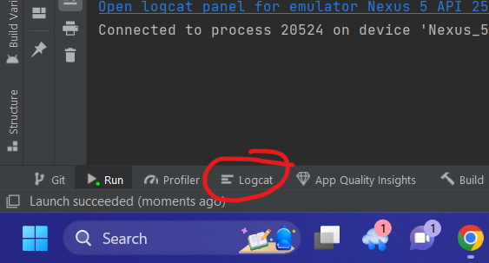

1. Click this and take a screenshot of the device and the output in the console log. The output should look like this:

